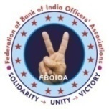 | THE BANK OF INDIA OFFICERS’ ASSOCIATION  [ MUMBAI & GOA ] |  | 
  Bank of India Building, 3rd Floor, 70-80, M. G. Road, Fort, Mumbai – 400 023.
  Tel.: 22644655 / Fax : 22671018 / Email : boioa.mumgoa@gmail.com / Website : www.boioamg.org
CIRCULAR NO.2019/04 |  | DATE : 06-02-2019

Dear Comrades,

We reproduce, hereunder, Federation Circular No.04 dated 06-02-2019 issued by General Secretary, Federation, for your information.

With warm regards,
Yours Comradely,
[ M. B. TRIPATHI ]
GENERAL SECRETARY

Circular No. 2019/04 Date: 06.02.2019
Dear Comrades,

QUOTE:
MAHA MORCHA BY AIBOC
ANOTHER MILESTONE IN BANKING TRADE UNION MOVEMENT

It was a sea of humanity that converged in the Capital City yesterday and inundated the streets. At the call of AIBOC, thousands of officers from Kashmir to Kanyakumari, from Ahmedabad to Aizawl, from Sikkim to Thrissur assembled to oppose against the ill-conceived proposal of amalgamation of Vijaya

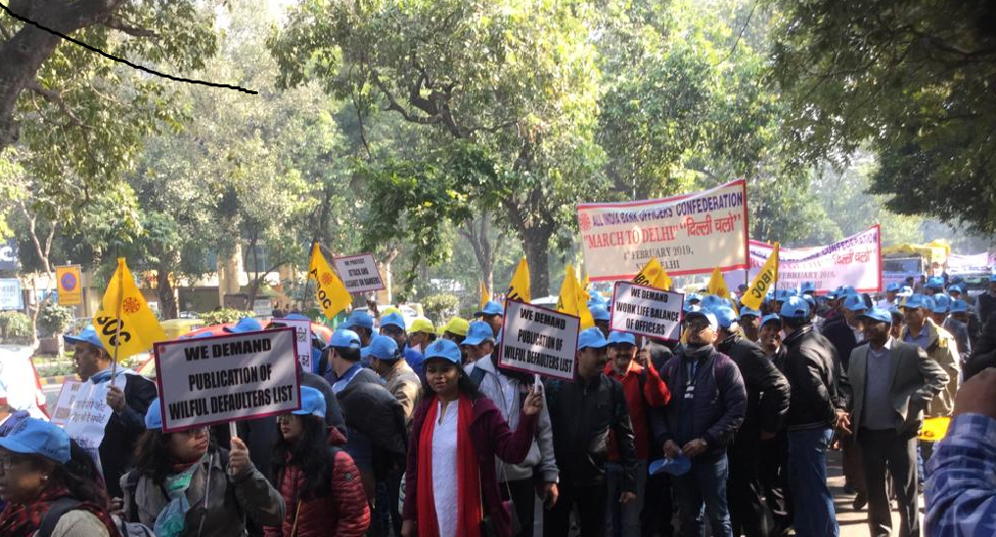

Bank, Dena Bank and Bank of Baroda, merger of RRBs, demanding decent and just wage settlement for officers as per the Charter of Demands based on Minimum Wages principle, abolition of NPS, Pension updation and family pension revision, protesting the atrocities of Management on Catholic Syrian Bank Officers and the retrograde decision to reduce their retirement age, demanding full mandate for Scale I to VII officers, opposing the mis-selling of third party products, attack and assault on bankers et al. This kind of massive turnout right on the heels of the Solo Strike on 21st December, 2018 has amply manifested the organization capabilities of AIBOC, displaying the solidarity and strength of the officers’ community of the Indian Banking Industry.

The Maha Morcha originated in the form of a massive ‘Jatha’ from Modern School, Barakhamba Road, Delhi, at 10-30 a.m. and proceeded towards Parliament Street (Sansad Marg) via Tolstoy Marg and finally culminated into the protest congregation at Jantar Mantar, Parliament Street. More than twenty
thousand officers and a significant number of retirees braved the inclement weather and joined the march protesting the anti-bank and anti-people policies of the government. The rally also witnessed the spontaneous participation of huge number of lady members and the youth, who chanted slogans all the way to the Parliament Street in support of our legitimate demands. Political and Central Trade Union leaders across the spectrum addressed the rally which included Shri Sanjay Singh, MP, Aam Aadmi Party, Shri N K Premachandran, MP Revolutionary Socialist Party, Shri Tapan Sen, General Secretary, CITU. This added an extra dimension to the protest programme.

.....1

:: 2 ::

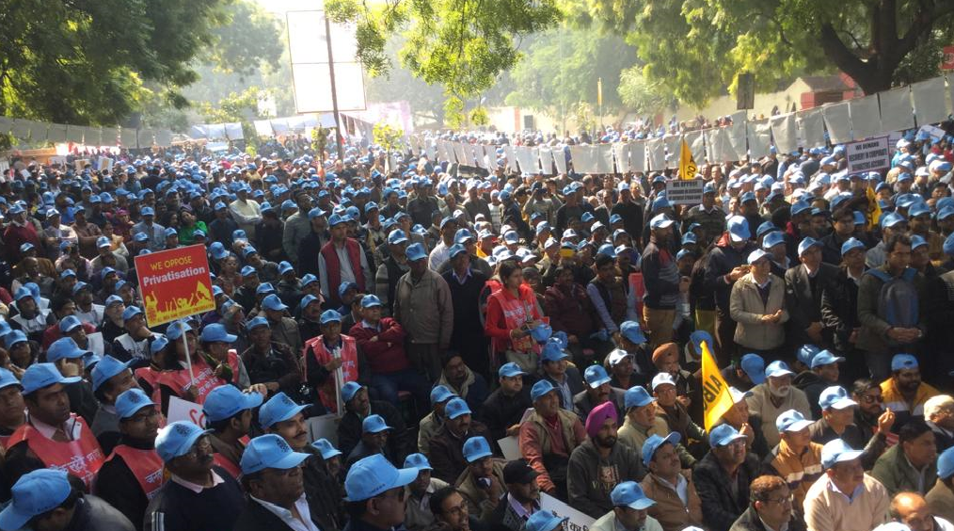

Leaders of fraternal organisations were also present to extend their support. Shri Subhas S Sawant, General Secretary, INBEF, Shri Debasish Basu Chaudhury, General Secretary, BEFI, Shri Amit Chandan, Jt. Secretary, NOBO, Shri Srikantha Mishra, Secretary, AIIEA Delhi State Unit, Shri Subhash Lamba, All India State Govt. Employees Federation, Delhi State Unit, Shri V K Tomar, President AIPCOC, Shri Sebastin K, General Secretary, SNEA (BSNL), Shri K V Acharya, General Secretary, CBPRO, Dr. Prasenjit Bose, eminent economist and social worker addressed the gathering in support of our movement. We acknowledge with gratitude their support to our cause. We place on record our deepest appreciation to AIBOC Delhi State Unit , who under the leadership of Com Sunil Kumar Bansal, Secretary and Comrade Ravinder Gupta, President, shouldered onerous responsibility to organize the programme in a befitting manner. Kudos to State Units of adjacent states, who also put in their earnest effort to mobilise thousands of members, who braved climatic hazards and attended our program.

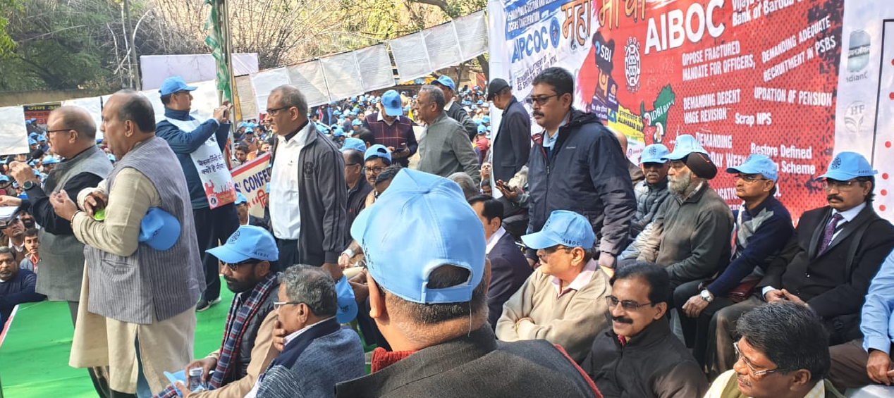

The march with the multitudes of participants brimming with such tumultuous enthusiasm and fervour has ignited the pent-up angst, frustration and unbridled passion of the officer community, which would fuel our movement to its logical conclusion and thwart the evil designs of the government. The tremor generated by the bold footsteps and the thunderous slogans that resonated across the National capital has definitely served a wake-up call to the government. AIBOC has firmly established that it is a force to reckon with as we are connected to 80 crore citizens of the country. The day of 4th February, 2019 would be engraved in golden letters in the annals of the history of officers’ trade union movement. The remarkable and resounding show of solidarity, dedication, grit, gumption and determination displayed by the participants was a clarion call to the powers to wake up from slumber and realise the magnitude of the challenge posed by AIBOC and also to realise that we are now a formidable opinion forming force in the country and we are confident that it is only a matter of time before our concerns would be heard and addressed.

We take this opportunity to again convey our sincere thanks and appreciation to all our affiliates for their unstinted support and making our Maha Morcha an outstanding success.

Keep up this momentum……….Ultimate victory shall be ours…………..
With revolutionary greetings,
Yours comradely,
Sd/-
(SUNIL KUMAR - GENERAL SECRETARY)
UNQUOTE

