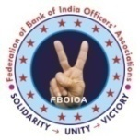 | THE BANK OF INDIA OFFICERS’ ASSOCIATION  [ MUMBAI & GOA ] |  | 
  Bank of India Building, 3rd Floor, 70-80, M. G. Road, Fort, Mumbai – 400 023.
  Tel.: 22644655 / Fax : 22671018 / Email : boioa.mumgoa@gmail.com / Website : www.boioamg.org
CIRCULAR NO.2019/29 |  | DATE : 31-12-2019

Dear Comrades,

We reproduce, hereunder, Federation Circular No.22 dated 31-12-2019 issued by President, Federation, for your information.

With warm regards,
Yours Comradely,
[ NILESH R. PAWAR ]
GENERAL SECRETARY

Circular No. 2019/22 Date: 31.12.2019

Dear Comrades,
Another Golden Era Dawns In Our Federation
Our Federation Shines Bright
Com. Sunil Kumar Elevated As President Of AIBOC.

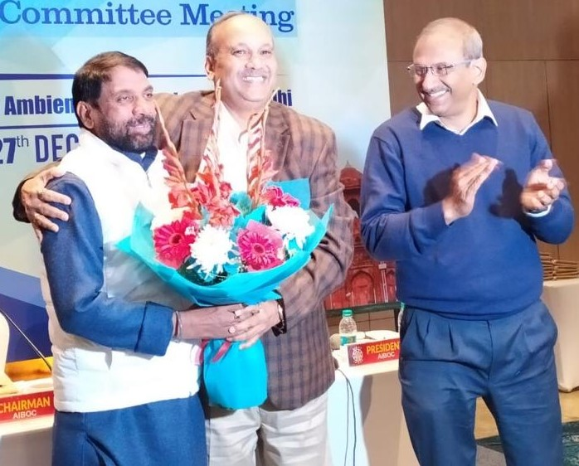

We are delighted to inform our members that Com. Sunil Kumar, Chairman – AIBOC and beloved General Secretary of our Federation has been elevated as the President of our mighty Confederation - All India Bank Officers’ Confederation - in the 92nd Executive Committee Meeting of AIBOC held at Delhi on 26th & 27th December, 2019. It is a true testimony of the leadership qualities of Com. Sunil Kumar which propelled him to the exalted position of the President of largest supervisory cadre Trade Union Body in the world. It was only in November 2018 that Com. Sunil Kumar was unanimously co-opted as Chairman of AIBOC. He succeeds Com. Debasis Ghosh of Union Bank of India who is superannuating today.

His elevation to the post of President has made us proud. It is a joyous occasion for all of us as he joins the league of illustrious leaders of our Federation like Com. S.R. Sengupta who co-founded and served the Confederation initially as its President and later as its General Secretary. In subsequent years Com. V. Eswaran and Com. Harvinder Singh also served as
President and General Secretary of AIBOC respectively. It is a true recognition of Com. Sunil Kumar’s astute leadership qualities and selfless service to the officers’ community.

The elevation of Com. Sunil Kumar assumes critical importance at a time when Public Sector Banks are braving crises of different dimensions. The threat of mergers and privatisation plans of the Government coupled with other anti-labour policies, requires a strong and resolute leadership and elevation of Com. Sunil Kumar has strengthened the hands of the General Secretary of Confederation Com. Soumya Datta.

Hearty congratulations to Com. Sunil Kumar on his richly deserved elevation. I join the entire officers’ community of Bank of India in wishing our General Secretary a very satisfying, successful and extraordinary innings and all the success in his future endeavours. We are also confident that Com. Sunil Kumar will propel AIBOC to greater heights in the coming days and the history of AIBOC would be etched in golden letters.

March on Comrade Sunil Kumar. Future belongs to those who dare!

With warm greetings,
Yours comradely,
sd/-
(Madhusudhana B.N.)
President



Optimism is the faith that leads to achievement. Nothing can be done without hope and confidence – Helen Keller

We wish all our Comrades a Happy, prosperous and fulfilling New Year. May the New Year usher in joy, success, and contentment to you and your family. Happy a great year ahead.

